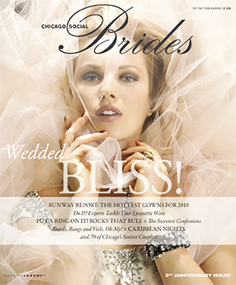

CS Brides Spring/Summer 2010

